Time for the Republic Services Falls City Annual
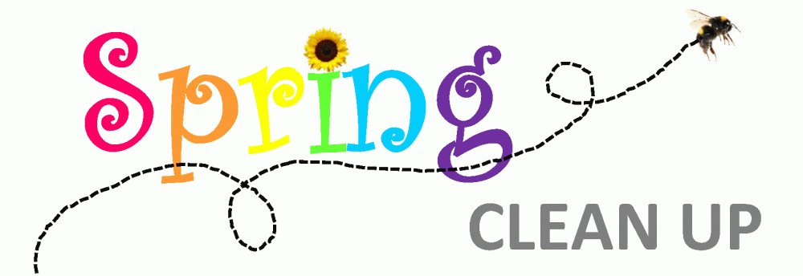
Date: Saturday June 05, 2021
Time: 8:00 AM to 2:00 PM
Location: Old Mill Public Works Lot at the corner of Parry Road and Bridge Street, across from the Post Office.
Form a line on Parry Rd. facing the Old Mill Lot.
We ask that you help our volunteers unload your junk unless you are a senior or disabled.
Anyone not already in line by 1:00 pm will be turned away.
Curb side pickup
For Senior & Disabled
Items Must be separated prior to arrival or you will be turned away.
Acceptable Items:
- General Junk
- Scrap Metal
- Empty clean appliances
- Electronics
- Yard debris- No dirt or sod.
- Tires:
Passenger & Light Truck
$1.50 off rim
$2.50 on rim

Semi-Truck
$5.50 off rim
$7.50 on rim
$.50 Tubes

Unacceptable Items:
- Boats, vehicles:
anything that requires a title.
- Household garbage, any liquids
- Hazardous waste including batteries.
- Brick, dirt, sod, concrete
- Coolers or appliances with rancid contents

To add your name to the list: Call 503.787.3631
Items must be left on the public right-of-way, and not on the road.
Unassigned piles will not be picked up by volunteers.

Volunteers Needed!
Neighbors helping Neighbors!
Help direct traffic; help load tires, haul for seniors.
Join the Fun! Call City Hall 503.787.3631
Thanks to donations by t Republic Services, volunteers will enjoy refreshments!
The City will provide gloves & donuts!
Lunch will be provided for volunteers.

